Unit 3 Retake 3B
- What is the solution of the linear equations? ( , ) or No Solution or Infinitely Many (IMS)
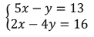

- What is the solution of the linear equations? ( , , ) or No Solution or Infinitely Many (IMS)
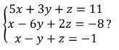

- What is the solution of the linear equations? ( , , ) or No Solution or Infinitely Many (IMS)
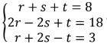

- What is the solution of the linear equations? ( , , ) or No Solution or Infinitely Many (IMS)

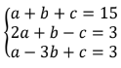

- What is the solution of the linear equations? ( , , ) or No Solution or Infinitely Many (IMS)

